Experiment 11
Write a program for the task of Credit Score Classification
Aim
To implement a Credit Score Classification program in Python to classify whether a person's credit score is Good or Bad based on given financial data.
Program
# Credit Score Classification
import pandas as pd
from sklearn.tree import DecisionTreeClassifier
from sklearn.metrics import confusion_matrix, accuracy_score
# Dataset
data = {
'Income': [30000, 40000, 50000, 60000, 35000, 70000, 80000, 45000],
'Loan': [10000, 15000, 20000, 25000, 12000, 30000, 35000, 18000],
'CreditScore': [0,0,1,1,0,1,1,0] # 0 = Bad, 1 = Good
}
df = pd.DataFrame(data)
# Features and Target
X = df[['Income','Loan']]
y = df['CreditScore']
# Model
model = DecisionTreeClassifier()
model.fit(X, y)
# Prediction
y_pred = model.predict(X)
# Confusion Matrix
cm = confusion_matrix(y, y_pred)
print("Confusion Matrix:\n", cm)

# Accuracy
acc = accuracy_score(y, y_pred)
print("Accuracy:", acc)

Output
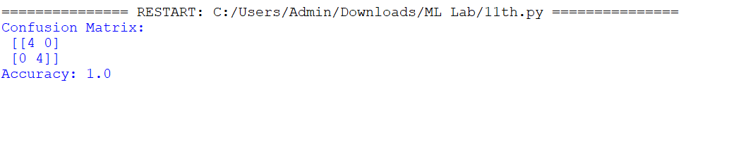

Result
The Credit Score Classification program was successfully implemented in Python, and the model classified credit scores with the help of a confusion matrix and accuracy score.

